Constraints
Given the two tables in the previous group lab complete the following:
1) Create a check constraint on salary greater than 10000 but less than 50000. Your constraint should be given a name
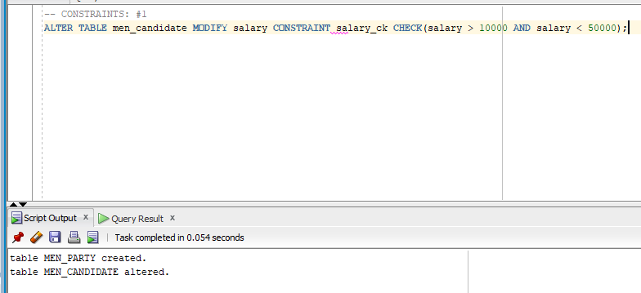

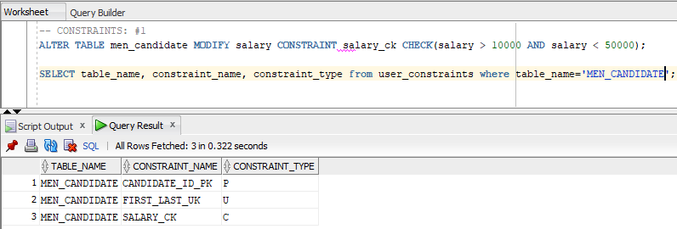
2) Add a not null constraint to PartyDesc. Do not give a name to your constraint
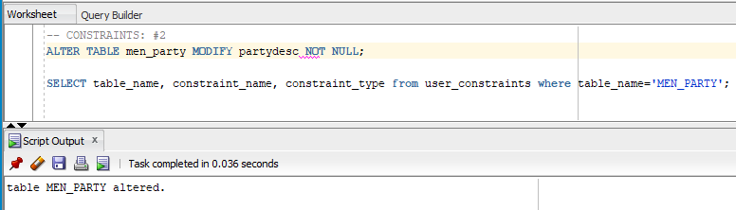

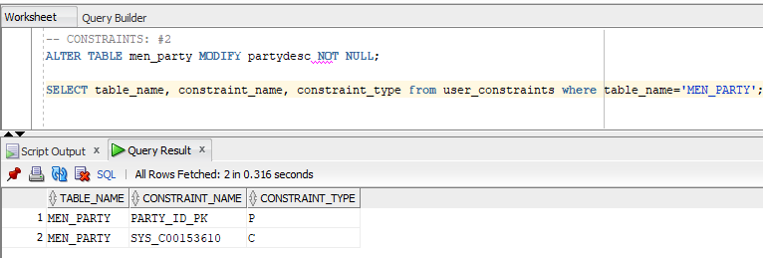
3) Disable the check constraint on salary
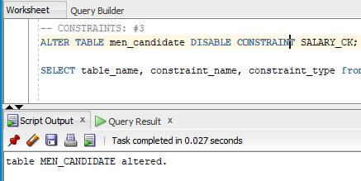

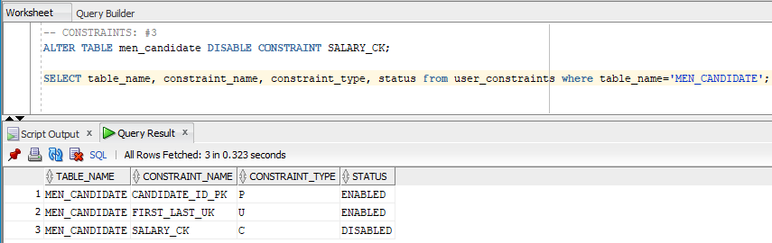
4) Add a foreign key constraint. You have to add an additional column to the proper table. Give your constraint a name (NOTE: Make sure you pick the right table)
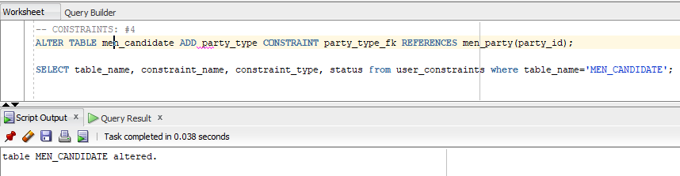

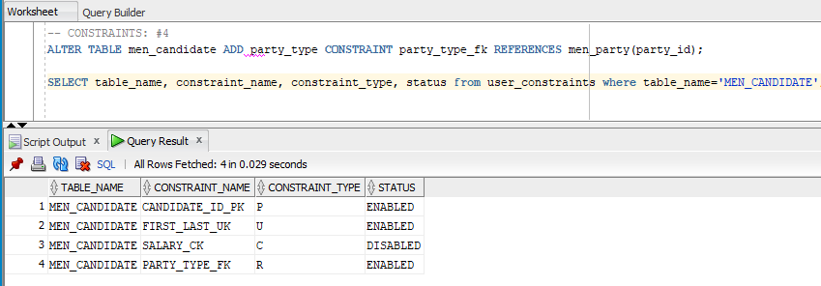
5) Disable the foreign key constraint
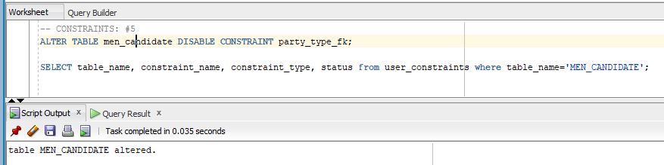
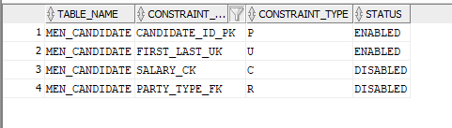

6) Drop the foreign key constraint
